**DAILY ONLINE ACTIVITIES SUMMARY**

|  |  |  |  |  |  |  |  |  |
| --- | --- | --- | --- | --- | --- | --- | --- | --- |
| **Date:** | **26-06-2020** | | | | | **Name:** | **Sinchana** | |
| **Sem & Sec** | **6 B** | | | | | **USN:** | **4AL17CS117** | |
| **Online Test Summary** | | | | | | | | |
| **Subject** | | **Cyber Security**  **Data structures** | | | | | | |
| **Max. Marks** | |  | | **Score** | | |  | |
| **Certification Course Summary** | | | | | | | | |
| **Course** | Cyber securityData structures | | | | | | | |
| **Certificate Provider** | | | **Dr.Manjunath**  **Mr.Venketesh** | | **Duration** | | | **4 hrs** |
| **Coding Challenges** | | | | | | | | |
| **Problem Statement: 1.permutation** | | | | | | | | |
| **Status: Success** | | | | | | | | |
| **Uploaded the report in Github** | | | | | **Yes** | | | |
| **If yes Repository name** | | | | | **coding** | | | |
| **Uploaded the report in slack** | | | | | **Yes** | | | |

Online Test Details: (Attach the snapshot and briefly write the report for the same)

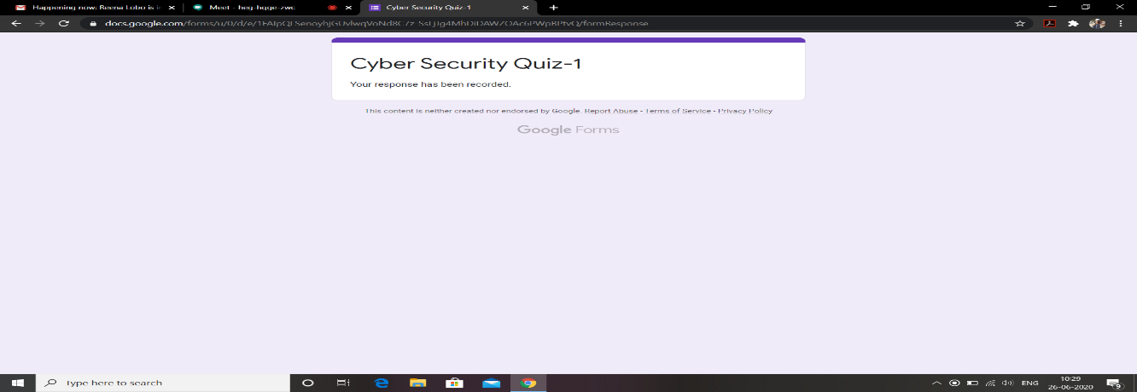

This is the response Cyber Security test and this is the snapshot of this.

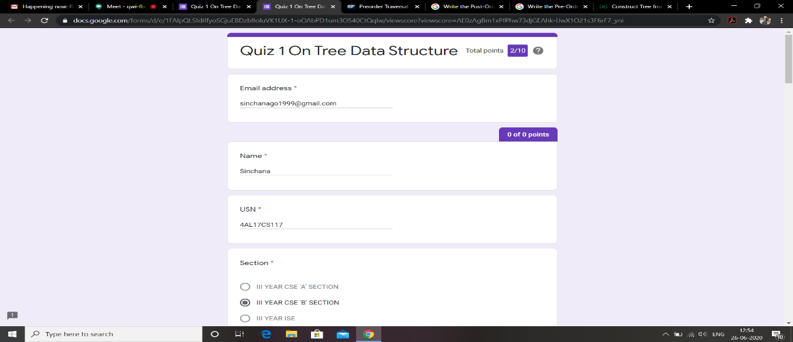

This is the response Data structure programming test and this is the snapshot of this.

Certification Course Details: (Attach the snapshot and briefly write the report for the same)

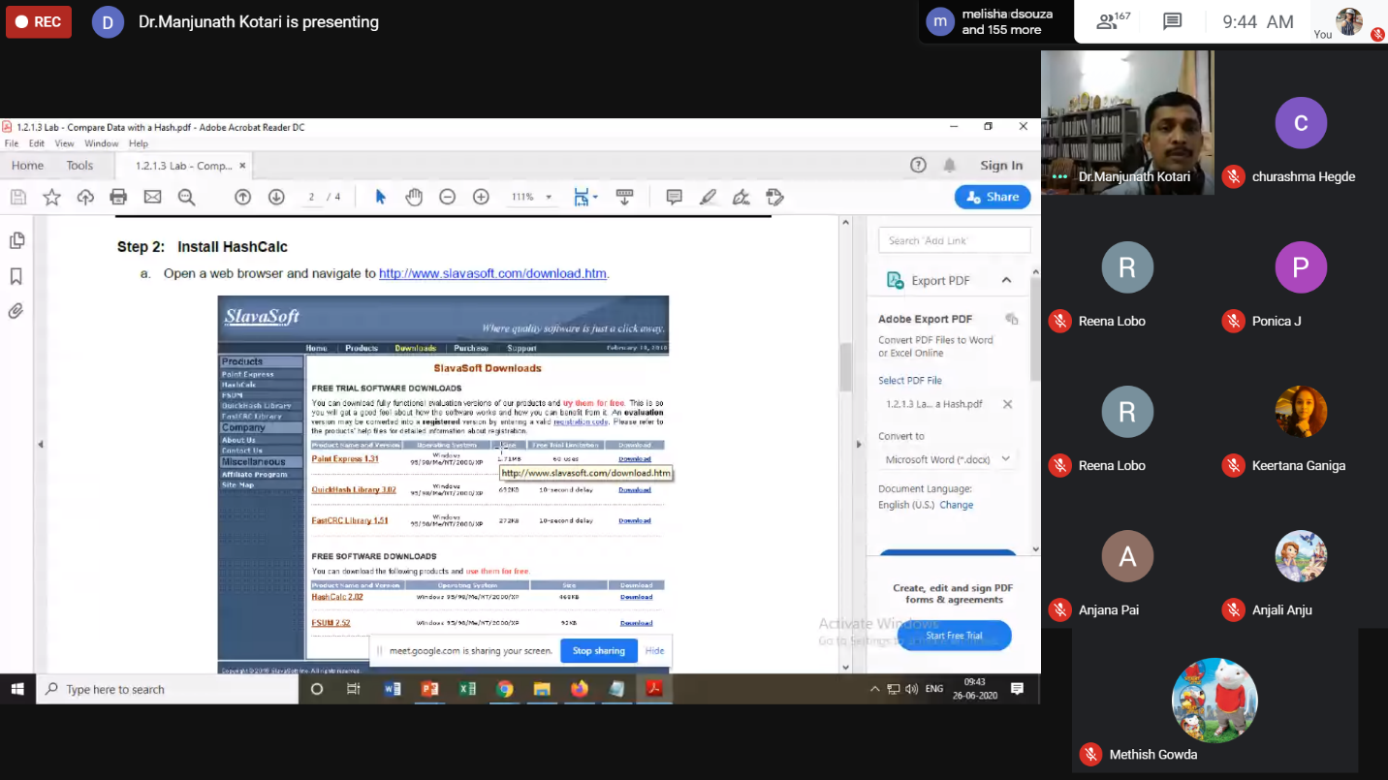

Today I have learnt about Cyber security in which there where several examples where explained.

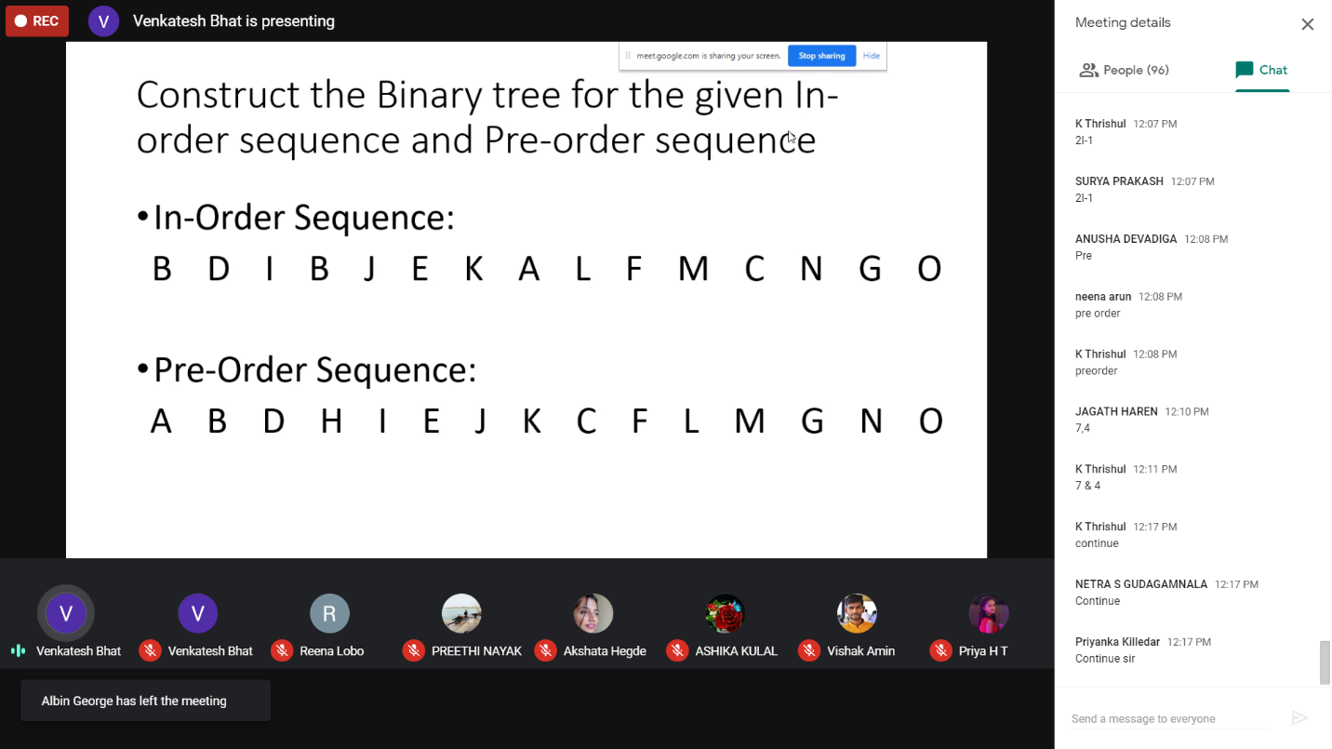

Today I have learnt about stack and queue and several examples where explained.

Coding Challenges Details: (Attach the snapshot and briefly write the report for the same)

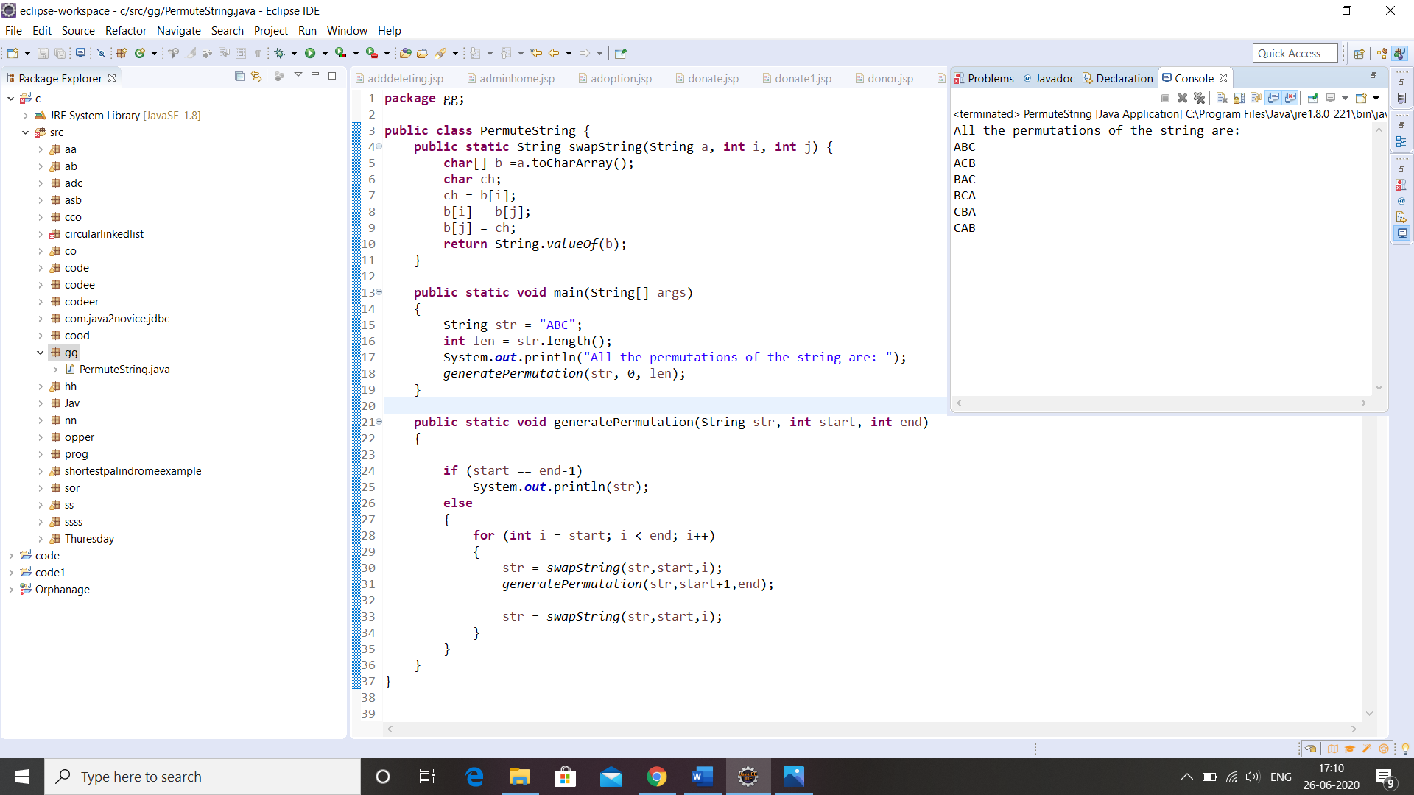

Link in Github :

1. Coding and Word document

<https://github.com/sinchana514/coding/tree/master/26th%20june>